**16. Kubernetes Deployment - Edit Deployment using kubectl edit**

--- Reference - <https://github.com/stacksimplify/kubernetes-fundamentals/tree/master/04-Deployments-with-kubectl/04-02-Update-Deployment>

--- **note** – this is the deployment we use in real time. This is very important method for deployment.

**Update the Application from V2 to V3 using "Edit Deployment" Option**

**# Edit Deployment**

--- **kubectl edit deployment/<Deployment-Name> --record=true**

--- **kubectl edit deployment/my-first-deployment --record=true**

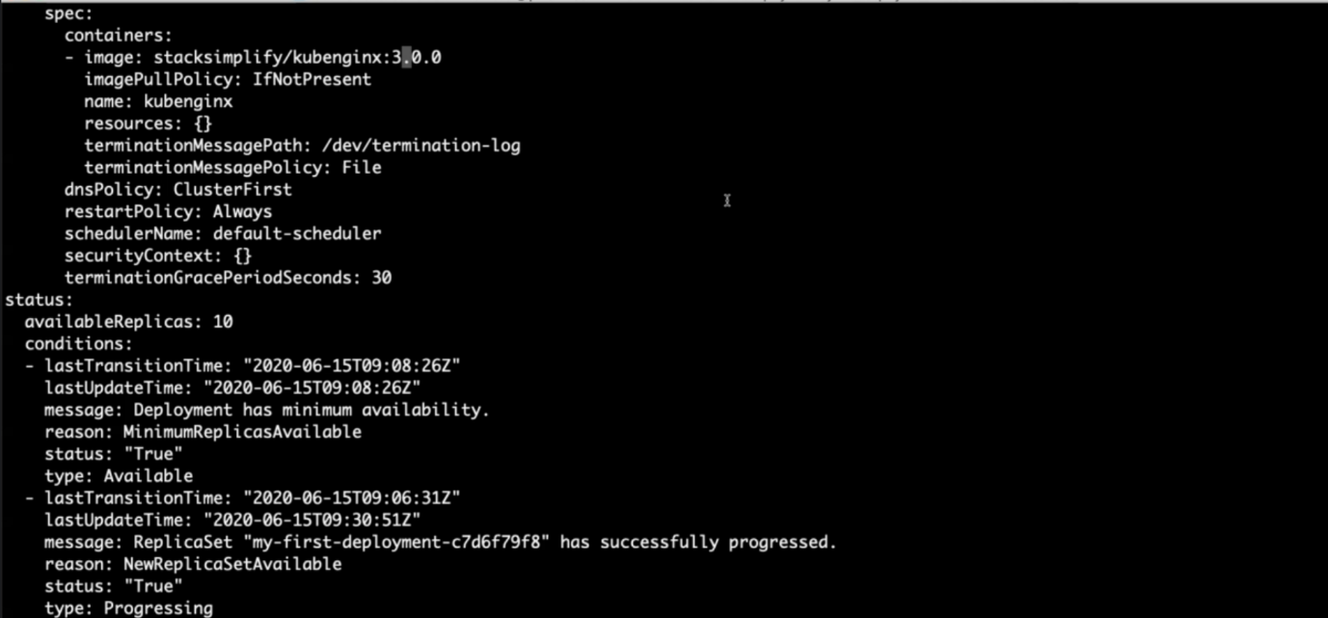

**# Change From 2.0.0**

spec:

containers:

- image: stacksimplify/kubenginx:2.0.0

**# Change To 3.0.0**

spec:

containers:

- image: stacksimplify/kubenginx:3.0.0

**Verify Rollout Status**

--- **Observation:** Rollout happens in a rolling update model, so no downtime.

**# Verify Rollout Status**

--- **kubectl rollout status deployment/my-first-deployment**

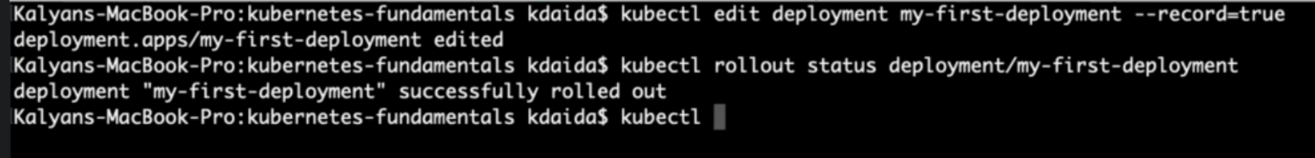

--- **note** – you don’t need to do anything to apply new changes to deployment. After you edited the deployment, the changes will automatically get applied.

**Verify Replicasets**

--- **Observation**: We should see 3 ReplicaSets now, as we have updated our application to 3rd version 3.0.0

**# Verify ReplicaSet and Pods**

--- **kubectl get rs**

--- **kubectl get po**

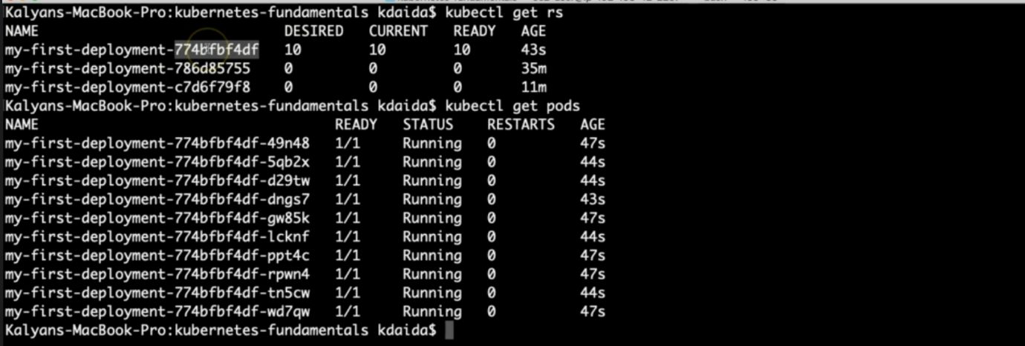

--- **note** – the pod label is pointed to the new replicaset.

**Verify Rollout History**

**# Check the Rollout History of a Deployment**

--- **kubectl rollout history deployment/<Deployment-Name>**

--- **kubectl rollout history deployment/my-first-deployment**

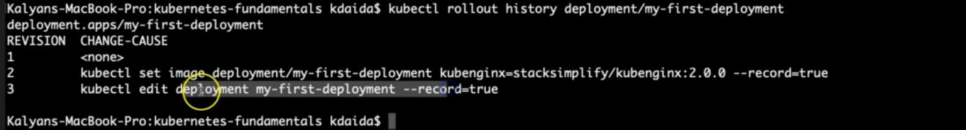

--- **note** – 3rd one is our latest deployment.

**Access the Application using Public IP**

--- **note** - We should see Application Version:V3 whenever we access the application in browser

**# Get NodePort**

--- **kubectl get svc**

--- **Observation**: Make a note of port which starts with 3 (Example: 80:3xxxx/TCP). Capture the port 3xxxx and use it in application URL below.

**# Get Public IP of Worker Nodes**

--- **kubectl get nodes -o wide**

--- **Observation**: Make a note of "EXTERNAL-IP" if your Kubernetes cluster is setup on AWS EKS.

**# Application URL**

--- **http://<worker-node-public-ip>:<Node-Port>**